Create Your Own Crossword Puzzle
Directions: You must create your own crossword puzzle with 20 questions, 10 up and 10 across.
Example: 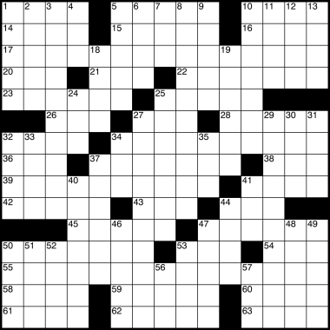
The following are the rules when creating the puzzle.
- Each question must be answerable
- There are no fill in the blank questions (ex: The period after the Civil War is known as _________)
- The more complex the question, the higher the grade!
- You may not put the words in the order they are listed (you will be doing each other’s puzzle.)
- Grammar and spelling count.
- You may use all or part of any definition.
- Thirteenth Amendment | - Jim Crow Laws
- Fourteenth Amendment | - Military Reconstruction Act
- Fifteenth Amendment) | - Radical Reconstruction
- Sharecropper | - Ulysses S. Grant
- Tenant Farmer | - Whisky Ring
- Andrew Johnson | - Compromise of 1877
- Freedman’s Bureau | - Hiram Revels
- Carpetbagger | - Black Codes
- Scalawag | - Impeach
- Reconstruction | - Tenure of Office Act
- Radical Republicans | - Redeemers
- Credit Mobilier | - Gold Ring
The following is your word bank

