Political Cartoon Assignment

Political cartoons have been used for many decades to poke fun or provoke thought about individuals or current events. Most political cartoons use caricature and satire to create humor. Caricature selects and exaggerates a characteristic of the subject of the cartoon. Satire uses sarcasm or irony to make fun of someone or some event.

Use your knowledge of the Gilded Age to develop a political cartoon of your own. Your cartoon can be funny or thought provoking or you can try and make your audience seriously rethink a position on an issue of the day. Before you begin there are a number of questions you need to think about, and answer, to create an effective political cartoon.

- What will the cartoon be about?
- Who are the main people involved in the event?
- How will you symbolize the groups or people involved to make them recognizable?
- What words or phrases will you use to communicate the message?
- What side of the event are you on?

Start your assignment by looking over our notes and Vocab on the Gilded Age. Does something about an event or person strike you as ironic or susceptible to satire? Once you have background knowledge in place, draw a rough sketch to create the exact message you want to convey.
Rubric
- 5 points for using symbolism
- 5 points for using at least one major issue of the time correctly
- 5 points for accuracy, completion, and neatness, and grammar (when applicable)
- Does not have to be colored

Examples:
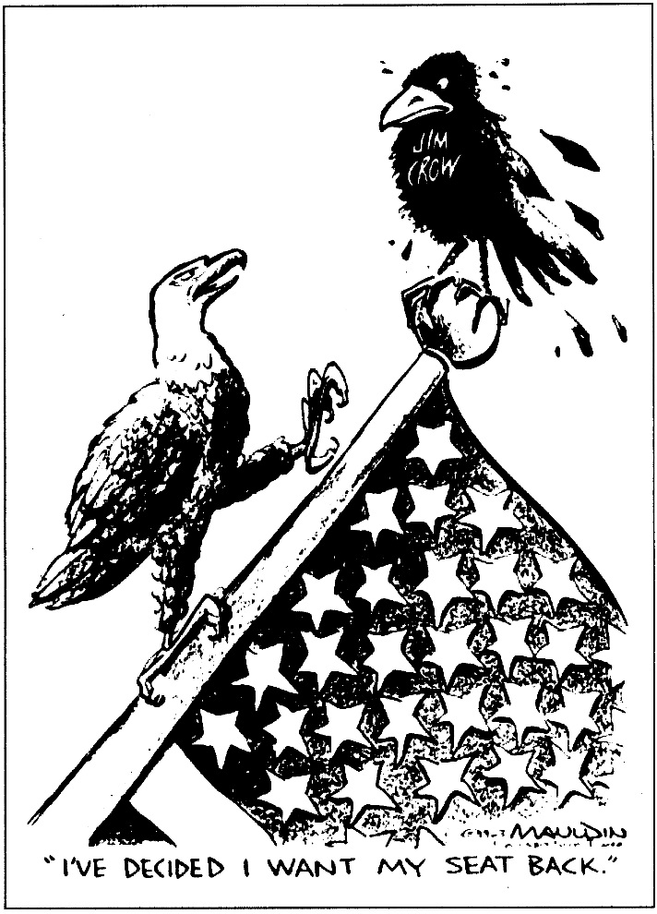
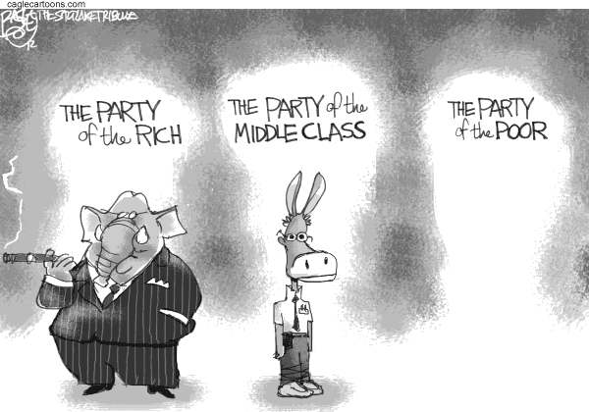

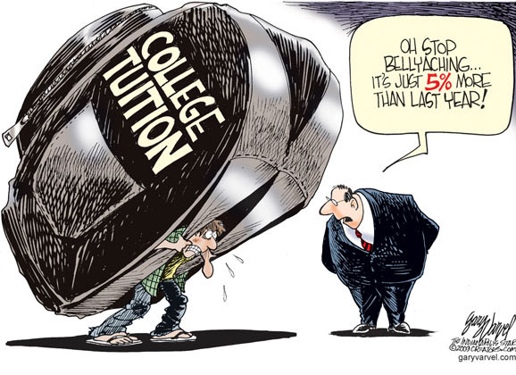
Jim Crow

