Historical Context
The year 1763 marked the end of the French and Indian War, the final defeat of the French and their Native American allies in America. For America's English colonists, this was a cause for great celebration and pride in their English identity. Expressions of English patriotism were widespread. But only twelve years later, these same American colonists found themselves locked in a bitter and violent conflict with the mother country that had so recently been the object of their proud respect. To this day, now over two hundred years later, the reasons behind this abrupt transition of England and its American colonies from allies to enemies are debated.

The following documents address the question of whether the American colonists were really justified in waging war against England. Examine each document carefully, and answer the question or questions that follow.

Document 1
This excerpt is from "Considerations ...," a pamphlet written by Thomas Whately, Whately was an advisor to George Grenville, British Chancellor of the Exchequer (1763-1765) and the author of the Stamp Act. In this pamphlet, Whately explained why the British were justified in levying taxes on their American colonists.
We are not yet recovered from a War undertaken solely for their [the Americans'] Protection ... a War undertaken for their defense only ... they should contribute to the Preservation of the Advantages they have received....

- Why did Whately (and probably most other English officials) feel that the American colonists should be willing to pay higher taxes to Parliament?

Document 2
These excerpts are from Letters from a Farmer in Pennsylvania by John Dickinson. Dickinson was a Pennsylvania political leader who served in the Stamp Act Congress of 1765. Later in his career, he served in the Continental Congress, and later still, in the Constitutional Convention. In the following statement, Dickinson condemned some of the new taxes being imposed by Parliament.

There is another late act of parliament, which appears to me to be unconstitutional, and ... destructive to the liberty of these colonies.... The parliament unquestionably possesses a legal authority to regulate the trade of Great Britain, and all her colonies. I have looked over every statute [law] relating to these colonies, from their first settlement to this time; and I find every one of them founded on this principle, till the Stamp Act administration.... All before, are calculated to regulate trade.... The raising of revenue ... was never intended.... Never did the British parliament, [until the passage of the Stamp Act] think of imposing duties in America for the purpose of raising revenue. [The Townshend Acts claim the authority] to impose duties on these colonies, not for the regulation of trade ... but for the single purpose of levying money upon us.

- According to Dickinson, what taxes was Parliament justified in imposing on the colonies?
- Why did he object to the Stamp Act and the Townshend Acts?

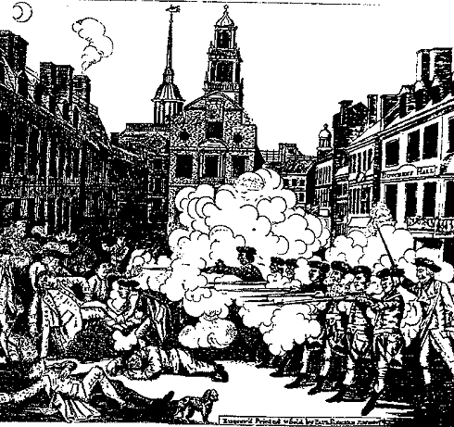
Document 3

On March 5, 1770, a crowd of Boston boys and men surrounded a number of British soldiers and began taunting and cursing them while they pelted them with snowballs. Order quickly broke down, and the frightened soldiers fired into the crowd. When the shooting ended, several people were dead and more were wounded. This engraving by Paul Revere, a leader of the Boston Sons of Liberty, was sent throughout the Colonies in the following weeks to arouse anti-British feelings.

- How does the engraving tell a different story from the above description of the Boston Massacre?
- Where do you suppose the term "massacre" came from that describes this event?

Document 4
In The Journal of Nicholas Cresswell, 1774-1777, Cresswell, a young Englishman, kept an account of his travels through the American Colonies. The following excerpts are dated October 19, 1774 and tell of his visit to Alexandria, Virginia.

Everything here is in the utmost confusion. Committees are appointed to inspect into the characters and conduct of every tradesman, to prevent them selling tea or buying British manufactures. Some of them have been tarred and feathered, others had their property burnt and destroyed by the populace.... The King is openly cursed, and his authority set at defiance.... everything is ripe for rebellion. The New Englanders by their canting, whining, insinuating tricks have persuaded the rest of the colonies that t the government is going to make absolute slaves of them.

- Who did Cresswell blame for the growing antagonism between the British and the American colonists? _

Document 5
This excerpt is from "Declaration of the Causes and Necessity of Taking up Arms." issued by the Second Continental Congress on July 5, 1775. The war had broken out in April, when British forces had marched to Lexington and Concord, two villages just outside of Boston. This document, written largely by John Dickinson and Thomas Jefferson, was designed to explain and justify the fighting that had continued since April.

[The British declare] that parliament can "of right make laws to bind us in all cases whatsoever." What is to defend us against so enormous, so unlimited a power? ... We are reduced to the alternative of choosing an unconditional submission to the tyranny of irritated [British officials), or resistance by force. - The latter is our choice.

- Why, according to this document, were the Americans justified in fighting the British?

Document 6
These excerpts are from Thomas Paine's Common Sense, published in January 1776. This popular pamphlet helped to convince many Americans that the conflict with England was beyond peaceful settlement and that independence was America's only course.

Men of passive tempers look somewhat lightly over the offenses of Great Britain, and, still hoping for the best, are apt to call out, COME, COME, WE SHALL BE FRIENDS AGAIN FOR ALL THIS. But ... then tell me whether you can hereafter love, honour, and faithfully serve the power that hath carried fire and sword into your land? ... No man was a warmer wisher for a [peaceful settlement] than myself, before the fatal nineteenth of April, 1775 [the battles at Lexington and Concord, Massachusetts, occurred on this day], but the moment the event of that day was made known, I rejected the hardened, sullen-tempered [King of England] forever.

- Why was Paine unwilling to be reconciled with Britain? __
- Was Paine an objective and unbiased reporter? Explain. _

Document 7
These excerpts are from "The Declaration of Independence," adopted by the Continental Congress of July 4, 1776.

The history of the present King of Great Britain is a history of repeated injuries and usurpations [unlawful seizures], all having in direct object the establishment of an absolute Tyranny over these States.
In every stage of these Oppressions We have Petitioned for Redress in the most humble terms; Our repeated Petitions have been answered only by repeated injury. A Prince, whose character is thus marked by every act which may define a Tyrant, is unfit to be the ruler of a free people.

- How does this document describe King George?
- Was the Declaration an objective and unbiased statement of the American-British conflict? Explain.

Were the American colonists justified in waging war and breaking away from Britain?

